Murrelet Survey Tool

Table of Contents

Introduction 2

Installation 2

Prerequisites 2

Project Folder Structure 3

Installing ArcGIS Mobile 4

Configuring the Murrelet Survey Tool 4

Starting the Mobile Application 5

Configuring the GPS 6

Changing Laptops in Mid-mission 7

Changing Data Recorders in Mid-mission 7

Operation 8

Yearly Configuration 8

Daily Operation 8

Data Collection Details 9

Initial map page 9

Moving around the map 10

Start Task 11

Track Log Setup 13

Record Track Log 15

Make Observations 17

Edit or Delete Observations 21

Misc Notes 22

Editing in ArcMap 22

Database Schema 26

Transects Feature Class 26

Tracks Feature Class 26

GpsPoints Feature Class 27

Observations Feature Class 28

BirdGroups Feature Class 28

Miscellaneous 29

Contact Information 29

Script Details 29

C:\KIMU\Scripts\1)InstallOrUpdateMachine.bat 29

C:\KIMU\Scripts\2)InstallOrUpdateUser.bat 29

C:\KIMU\Scripts\3)SyncUser.bat 29

C:\KIMU\Scripts\4)ExportToCSV.bat 30

C:\KIMU\Scripts\5)SnapshotToZip.bat 30

Field Checklist 30

Notes 30

Cautions 30

Trouble Shooting 31

# Introduction

The Murrelet Survey Tool is a custom ArcGIS Mobile project which assists in the data collection for murrelet inventories in Glacier Bay National Park. It uses a GPS device to continuously track the location of the survey crew and the location and details of each bird group observation. Field data is synchronized with a fully relational ArcGIS file geodatabase, and can be exported to a CSV file for archival and analysis by third parties. The data collection protocol utilizes angle and distance to locate each bird group relative to the centerline of the boat.

ArcGIS Mobile is a customizable ESRI product for collecting field data on mobile devices (in this case a laptop computer) and synchronizing the mobile data with a master GIS database (in this case also on the laptop computer).

# Installation

## Prerequisites

1. Laptop with 64 bit Windows 7 Enterprise Edition installed[1].
2. ArcGIS Desktop 10.2 installed with a standalone license for ArcEditor or ArcInfo.
3. Ability to receive NMEA sentences from your GPS device on your laptop’s COM port. See Configuring the GPS for details.

## Project Folder Structure

Everything else required for using the Murrelet Survey Tool is installed in the C:\KIMU folder. The contents of this folder may be copied from one computer to another[2], or installed from one or more zip files. Once correctly installed, the contents of the C:\KIMU folder will look like the following:

1. 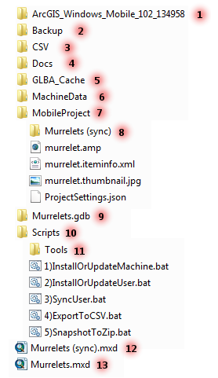The contents of the ArcGIS Mobile installation DVD. This folder is about 100MB in size and may be delivered as a separate zip file. This is the minimum version number required.
2. This folder contains a zip file for every day that script 5 is run. Each zip file contains a current copy if items 3 and 9 and is named by the day it ran.
3. This folder contains the CSV export file
4. Includes this help file, and computer code used to create this application.
5. A folder containing the application files that must be administratively installed in the systems folders. This is done by script 1.
6. Configuration, data and cache for the mobile application. Prior to 10.2 this folder was called UserData, and was copied to the user’s private profile.
7. Background imagery. This folder is about 1GB in size and may be delivered as a separate zip file.
8. The mobile cache. Created with script 2, synced with item 9 with script 3.
9. The file geodatabase containing the master copy of the project data. It is described in the Database Schema section.
10. A folder of the automation scripts. These scripts are described later in this document
11. The tools folder contains programs used by the scripts and does not need to be accessed directly
12. The ArcMap document used for syncing item 9 and the data recorder’s mobile cache. This document defines the look of the data in the application.
13. This ArcMap document is used for viewing and editing the project data, see the section Editing in ArcMap for more info.

## Installing ArcGIS Mobile

1. Right click the file C:\KIMU\ArcGIS_Windows_Mobile_vvvv\ESRI.exe and select **Run as administrator** 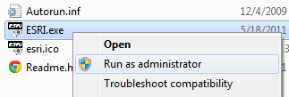
2. Select Setup for ArcGIS Mobile on the splash screen (the version number will be different)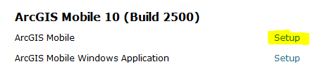
3. Select all the installation defaults until finished.

## Configuring the Murrelet Survey Tool

1. 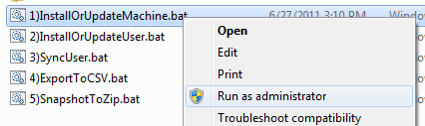Right click the file C:\KIMU\Scripts\1)InstallOrUpdateMachine.bat and select **Run as administrator. This will copy files from** C:\KIMU\MachineData to C:\ProgramData\ESRI\ArcGIS Mobile\Extensions**. For testing, replace** AnimalObservations.dll **with a testing version (i.e.** AnimalObservations-JuneauTesting.dll**). The file in** C:\ProgramData\ESRI\ArcGIS Mobile\Extensions **must be named** AnimalObservations.dll**. The testing versions offset the GPS coordinates to relocate the Juneau or Anchorage offices at the East end of transect 001. If you are unsure which** dll **is in** C:\ProgramData\ESRI\ArcGIS Mobile\Extensions**, right click and select properties then the details tab. The file description will identify if it is a testing** dll**.**
2. A command window should appear with the following message 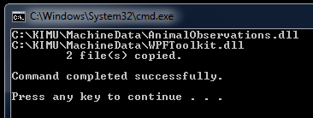
3. Close the window by clicking the close button.
4. Steps 4 to 7 only need to be run when Murrelets (sync).mxd is changed. The script will create the folder C:\KIMU\MobileProject\Murrelets (sync). It is an error if this folder already exists, so if you change Murrelets (sync).mxd, then delete C:\KIMU\MobileProject\Murrelets (sync), before running this script. **Caution: Any mobile data collected since the last sync (script 4) will be lost**. There is now (with version 10.2) only one mobile cache for all users of the computer.
5. Double click the file C:\KIMU\Scripts\2)InstallOrUpdateUser.bat
6. A command window should appear displaying the progress of several copy/sync operations. In the end it should look similar to the following: 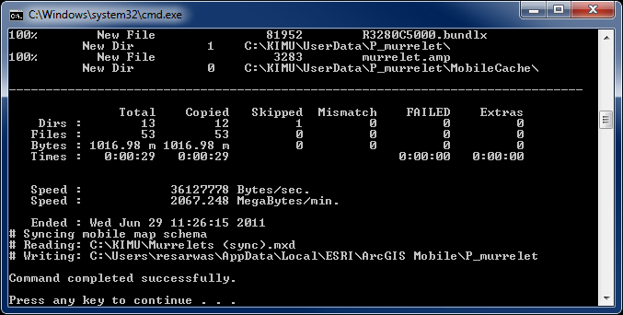
7. Close the window by clicking the close button.
8. Double click the file C:\KIMU\Scripts\3)SyncUser.bat
9. A command window should appear with a similar message 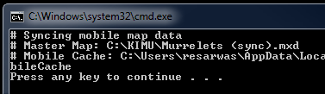
10. Close the window by clicking the close button.

## Starting the Mobile Application

The easiest way to start the application is to double click the file C:\KIMU\MobileProject\ murrelet.amp. This will launch ArcGIS Mobile, and open the project file. ArcGIS Mobile can also be launched from the start menu. After the first launch, it will open the previously open project. The first time you launch ArcGIS Mobile, it must be configured to recognize the folder C:\KIMU as a project folder. If you launched the application by double clicking C:\KIMU\MobileProject\ murrelet.amp, then you will see the following on the first launch:

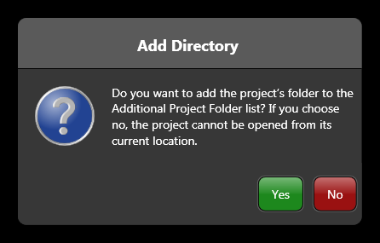

Simply click **Yes**, and you are done. If your first launch is from the Start Menu, then you must select **Change Settings** in the App’s home screen. From there, add C:\KIMU to the list of **Additional Project Folders**.

## Configuring the GPS

The GPS device you use must be configured to output NMEA sentences. The following instructions explain how to do this on a Garmin GPSmap 76CSx

1. Press the menu button twice
2. Use the center button to highlight the **Setup** option then press the enter button
3. Use the center button to highlight the **Interface** option then press the enter button
4. In the **Serial Data Format** pick list select **NMEA In/NMEA Out**
5. Press Quit button 3 times to return to main screen

The GPS device you use must be configured to use true north when reporting the bearing. The following instructions explain how to do this on a Garmin GPSmap 76CSx

1. Press the menu button twice
2. Use the center button to highlight the **Setup** option then press the enter button
3. Use the center button to highlight the **Heading** option then press the enter button
4. In the **North Reference** pick list select **True**
5. Press Quit button 3 times to return to main screen

The GPS device you use must be configured to use WGS 84 as the map datum. The following instructions explain how to do this on a Garmin GPSmap 76CSx

1. Press the menu button twice
2. Use the center button to highlight the **Setup** option then press the enter button
3. Use the center button to highlight the **Units** option then press the enter button
4. In the **Map Datum** pick list select **WGS 84**
5. Press Quit button 3 times to return to main screen

To connecting the GPS to a laptop, there are three main options depending on the GPS and the laptop. Exact details need to be worked out based on the available hardware. There are three main options.

1. If the laptop has a serial COM port (9 pin), and the GPS device has a serial cable then plug the serial cable into the com port.
2. If the GPS device has a serial cable, but the laptop only has a USB port, you can buy a USB serial port adaptor (aka port replicator). Plug the serial cable from the GPS into the port adaptor, and plug the port adaptor into the USB on the laptop.
3. If the GPS device only has a USB cable. Plug the USB cable into the USB port on the laptop, and install and turn on a virtual COM port driver. A free option is Franson GPSGate (<http://gpsgate.com/products/gpsgate_client>)

## Changing Laptops in Mid-mission

Should you choose to switch laptops for some reason during a single field season, the following instructions will get a new laptop set up and ready to collect data.

1. Ensure that you have run script 3)SyncUser.bat on the old laptop.
2. Follow all the instructions for setting up a new laptop.
3. Replace the C:\KIMU\murrelet.gdb folder and contents on the new laptop with the same folder and contents from the old laptop.
   1. If the old laptop is unavailable, then extract this C:\KIMU\murrelet.gdb from the most recently available backup file (originals are created in C:\KIMU\Backup, and should be available on a backup device)
   2. If the modified copy of C:\KIMU\murrelet.gdb from the original laptop is currently unavailable, you can either
      1. Start with an empty version (installed by default), and have a GIS specialist merge the old and new versions of C:\KIMU\murrelet.gdb once the mission is complete. If the old version of C:\KIMU\murrelet.gdb is permanently lost, then you need to plead with a GIS specialist to recreate the original data from the last CSV export.
      2. If there are no backups, or part of the work is missing from the most recent backup, then you either need to resurvey the missing work, or forgo that data.

## Changing Data Recorders in Mid-mission

Starting with version 10.2) only one mobile cache for all users of the computer. All the mobile data, including imagery is located in C:\KIMU. All users of the laptop will see the same mobile data. No special operations are required if two different users of the laptop collect data.

# Operation

## Yearly Configuration

Each year the transects that should appear in the Murrelet Survey Tool will be different than the year before, and most likely, the data recorder will not want to see data collected in previous years. To accomplish this use the following procedure:

1. Open the file C:\KIMU\Murrelets (sync).mxd in ArcMap.
2. For each item in the table of contents:
   1. Double click the item or right click and select Properties…
   2. Select the Definition Query tab
   3. Edit the definition query to select the appropriate data for the coming year
3. Save and Close ArcMap.
4. Have each data recorder run C:\KIMU\Scripts\2)InstallOrUpdateUser.bat and then C:\KIMU\Scripts\3)SyncUser.bat.

In addition, each year you should verify that the clock and the time zone on the laptop are set correctly. The time zone is used to GPS time to local time.

## Daily Operation

The following is a summary of the steps performed by the data recorder each day. Details are in Data Collection Details. The following steps can be repeated more often than every day. To ensure better coverage of the data on the backup devices, you could repeat these step as often as every transect.

1. Run C:\KIMU\Scripts\3)SyncUser.bat to ensure that your mobile cache and the master database are in sync. This first step will almost always be redundant and can usually be skipped. If you aren’t sure, then just do it. It can’t hurt to do it more often than required.
2. Turn on the GPS
3. Start the ArcGIS Mobile application
4. Collect data, see Data Collection Details.
5. Stop Recording
6. Close ArcGIS Mobile
7. Run C:\KIMU\Scripts\3)SyncUser.bat to push the newly collected data into the master database.
8. Run C:\KIMU\Scripts\4)ExportToCSV.bat to create C:\KIMU\CSV\2011.csv, where 2011 will change based on the current year.
9. Run C:\KIMU\Scripts\5)SnapshotToZip.bat to create C:\KIMU\Backup\2011-06-29.zip where the file name will change to reflect the current date (if this step is done more than once per day, the older file is overwritten).
10. Copy the zip file created in the previous step to one or more backup devices.

See the section on Script Details in the Miscellaneous section for additional information on the scripts, specifically when they should be run, and conditions that may cause an error.

## Data Collection Details

### Initial map page

When the application starts, it should look something like the following: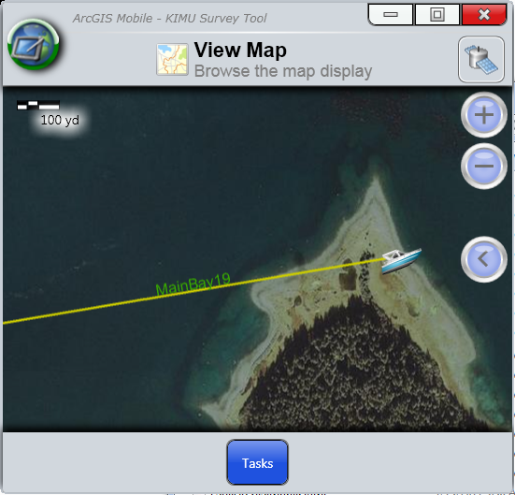

If the GPS device is on, receiving a signal, and you are within Glacier Bay, then the application should pan to your location and draw a boat icon at your current location. If you do not see the boat, make sure the GPS device is on, and then try to reconnect as described below.

The application should automatically try and connect to the GPS, however if this option was turned off, or if the GPS was not on when the application started, then you must manually connect to the GPS by clicking on the satellite button and selecting Connect to GPS 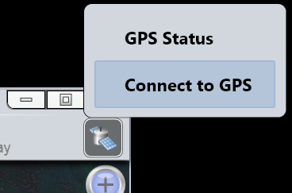

### Moving around the map

The map will automatically pan when the boat gets close to an edge of the map, however if you want to pan manually, simply use the mouse to click and drag the map. Be aware, that if you pan the boat too close to the edge of the map while the GPS is connected, the map will soon ignore your pan in order to put the boat back in the center. Disconnect the GPS if you wish to explore the map.

You can zoom in/out with the scroll wheel on the mouse, or the scroll bar on the laptop trackpad. You can also use the  Buttons to zoom in/out respectively.

Other map viewing options are available with the  button. These options are seldom required, and largely self explanatory. If you need additional help, please consult the ArcGIS Mobile help.

### Start Task

To start the task, first zoom out until the transect you are going to collect is within view (presumably you are already close to it), then click the blue Tasks button and select Collect Observations. 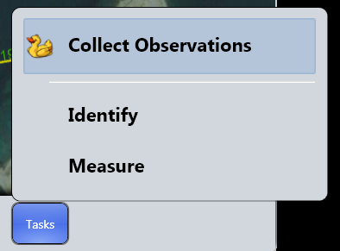

The other two other available tasks (Identify and Measure) are not used in this application. If you want to know more about using them, please consult the ArcGIS Mobile help.

If there the GPS is not connected, or there is no GPS signal the task will fail to start with the following error message:

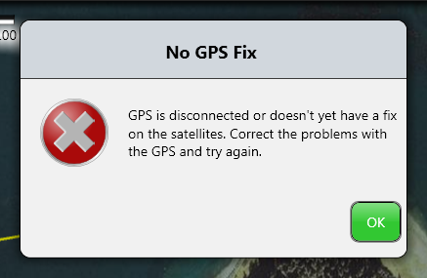

If there is no transect in the view, then the task will fail to start with the following error message:

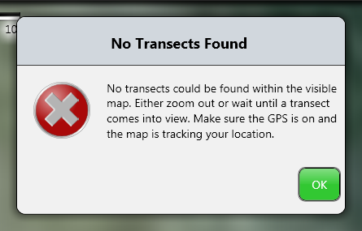

### Track Log Setup

Once the task starts successfully, you will be presented with the following data entry screen: 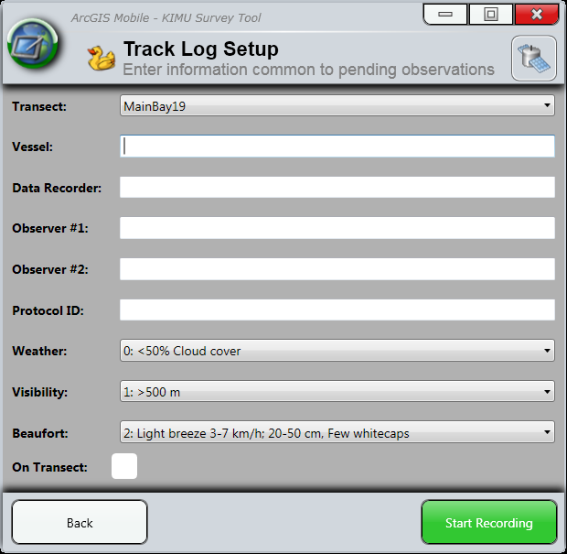

The transect pick list will be limited to only those transects that are within the map view. This list will update every time this page is reloaded. The default transect will be one closest to the boat when this page was loaded. In a given session, this form will remember values, so as you stop and start track logs you will only need to enter the information that has changed. The form will not remember your previous values when you quit the application.

The form will always have valid (although not always useful) values, so you can start recording at any time by clicking the green Start Recording button, or pressing the enter key.

To cancel the task and go back to the initial map page, click the Back button, or press the escape key.

#### Keyboard Navigation

The application was designed to require minimal mouse input. The form on this page can be navigated using the keyboard shortcuts discussed below. When the cursor is in a text box then that text box has focus, and any keyboard entry will go into that text box. If a pick list or check box has keyboard focus then it is outline with a light gray dashed line, as shown here:  and 

To move from field to field, use the tab key to go to the next field, use shift-tab to go to the previous field. Pressing tab at the bottom of the page will take you back to the top, and pressing shift tab at the top of the page will take you back to the bottom.

To go to a specific field use the Alt key plus the underlined letter of the field you wish to navigate directly to. For example, when you press the Alt key, the letter W in Weather is underlined.  If you press the W key while the Alt key is depressed the cursor will move to the Weather field. Each field has a keyboard shortcut that is revealed while pressing the Alt key.

Escape at any time will take you back to the initial map page.

Enter at any time will take you to the next screen and start recording the track log. Enter will not advance you from one field to the next (that is the job of the tab key). Remember not to press the enter key until you are ready to start recording.

When keyboard focus is on a pick list, you can switch the select item by using the arrow key, or entering the first character(s) of the displayed text. Note that keys in quick succession will be interpreted as one word, so you can differentiate pick list items that have similar beginnings. As a consequence typing 1-2 will select not select the item starting with 1 then the item starting with 2. It will look for the item starting with ‘12’, and not finding it will select the closest match, the item starting with 1. To start a new selection, just introduce a short (1 second) pause between characters. If you want to see all the items in the pick list at once, press the F4 key. When the full list is displayed, you can use tab/shift-tab, the arrow keys and the initial characters to move the focus around the list. To finalize your selection and dismiss the list, press the enter key.

When keyboard focus is on a check box, the space bar will toggle the option on/off.

When focus is in a text field, the all of the standard editing shortcuts (ctrl x/c/v for cut copy and paste, ctrl-z for undo, ctrl-a for select all, etc) work as expected.

### Record Track Log

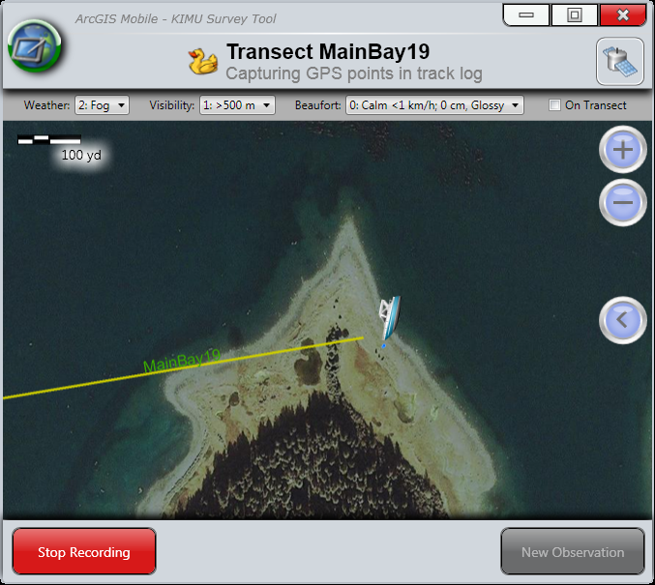

When the Record Track Log page appears, the application starts recording GPS points every 2 seconds. These points appear on the screen as blue dots. It is also creates a trail (or track) based on those points which it draws in red. It will continue tracking your location until you click the red ‘Stop Recording’ button, (or press the escape key). From this screen, you can change the Weather, Visibility, Beaufort, and On Transect flag at any time. If need to change any other track log attributes, you will need to stop recording, make the change on the Track Log setup page, and then click the start recording button on that page.

The Weather, Visibility, and Beaufort pick lists and the On Transect check box follow all the same keyboard navigation shortcuts discussed in the previous section.

You cannot begin making observations until you are on transect. It is a good idea to leave the On Transect check box cleared on the Track Log Setup page (It is off by default). Then when you start recording you can see the relationship of the boat to the transect. The data recorder can then assist the pilot in navigating the boat to the start of the transect. When the boat is at the beginning of the transect, the data recorder can toggle On Transect to checked, and clear the observers to begin.

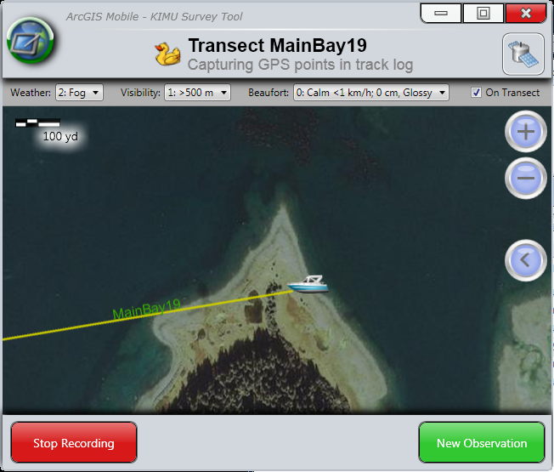

You can use the same map navigation feature discussed in the previous section, however in general once you have set an appropriate zoom level, the map screen will follow the boat, and you will not need to do any manual map navigation.

When an observer calls in an observation, click the Green ‘New Observation’ button, or press the enter key. The application will immediately place an observation on the most recently collected GPS Point, and change to the Edit Observation Attributes Page. The application uses the most recent GPS Point, because it is on average 1 second old (between 0 and 2 seconds), and that is a reasonable estimate for the amount of time that elapsed between the observer making the observation, and the data recorder recording the observation. To try and be anymore exact would require too much communication and potentially introduce unbounded errors.

### Make Observations

When the data recorder clicks the Green ‘New Observation’ button, or presses the enter key in the Track Log Recording Page, the application switches to the Edit Observation Attributes Page which initially looks like the following.

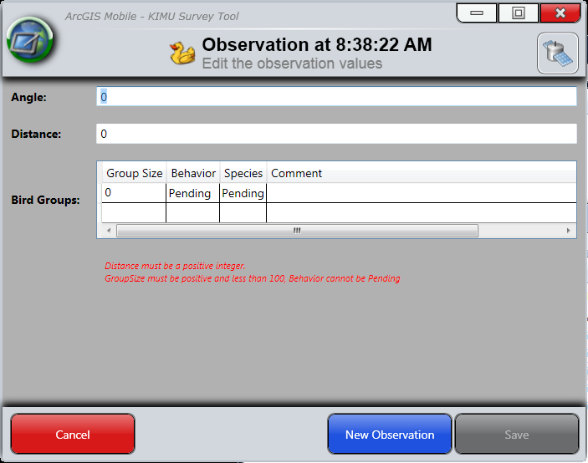

At this point the data recorder will typically enter the observation information. If the observer wishes to cancel or retract the observation (perhaps the birds were not murrelets), the data recorder can press the escape key or click the red ‘Cancel’ button to delete the current unfinished observation and return to the previous page (either the Record Track Log Page, or another observation as discussed below).

The application will not let you save an observation until the observation is valid. When the observation is invalid, the Save button is grayed out, and there is an red error message on the page, explaining what is wrong. For an observation to be valid it must meet the following criteria:

* Angle must be an integer between 0 and 360 inclusive
* Distance must be a positive integer less than 500
* There must be at least one bird group
* Each bird group must be valid, a valid bird group is one in which
  + The group size is a positive integer less than 100
  + The behavior is not pending

There can be any number of bird groups associated with an observation, and the grid will expand to accommodate them. To start a new bird group, simple tab or arrow to the empty row at the bottom of the grid, and enter a group size. This will create a new bird group, and add a new blank line to the bottom of the grid. If you want to remove a bird group from an observation, select the entire row and press the delete key.

Once there is a valid observation, then the Save button will go from gray to green and the observation can be saved. To save the observation, click the green save button, or press Ctrl-S. The enter key is not a reliable shortcut for saving the observation (see the section on keyboard navigation for more information). When the observation is saved, the active observation will be closed and you will be presented with the previous page.

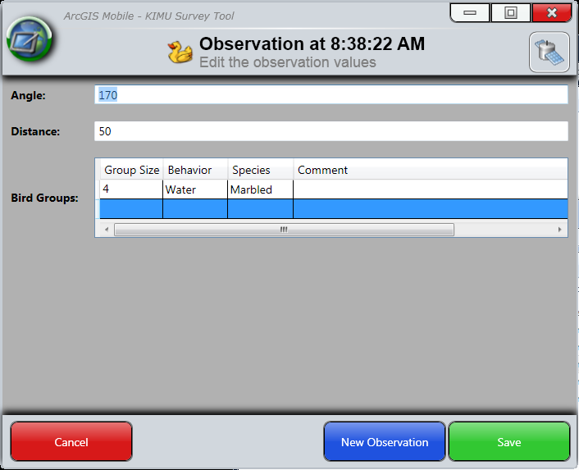

In most cases, the previous page is the Track Log Recording page, however you may have multiple active observation, so the previous page may be the Edit Observation Attributes Page with a different open observation.

It is not important to close an observation immediately. The application will continue to track the location of the boat and record GPS points and the track in the background. You may wish to leave an observation open for an indeterminate amount of time until the observer can positively determine the species. If either observer makes a new observation while there is an unfinished observation, the data recorder has two choices

1. If the observation is valid (species = pending is valid) then the observation can be saved, and when the Record Track Log screen reappears, then press the green ‘New Observation’ button to begin the new observation. If the data recorder needs to update the first observation, for example to update the species, they can select the observation for editing from the Record Track Logs Page as discussed below in the section on editing.
2. Regardless of the validity of the observation the data recorder can always click the blue ‘New Observation’ button, or press the Ctrl-N key combination. This will put the active observation in the background, and open a new observation just as if the observation had been made from the Record Track Log page. The Edit Observation Attributes page will look like the following:

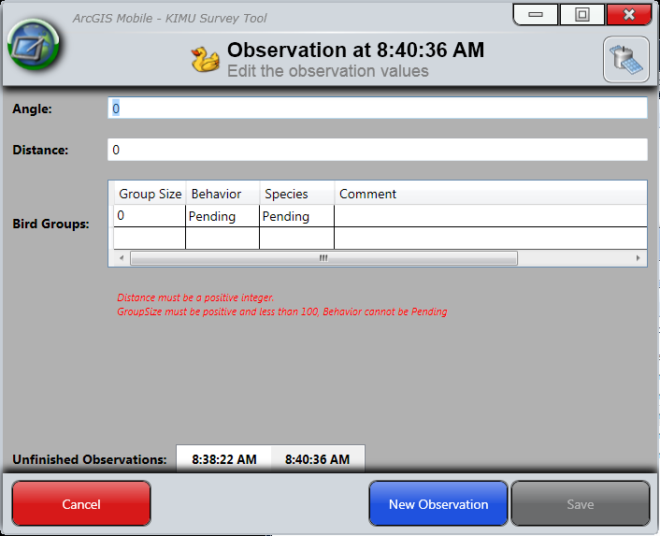

The open observation are identified by the time they were made. The time of the observation you are working on is in the title of the page. It is also highlighted in the list of unfinished observations at the bottom of the page.

To switch between observations, either use the mouse to click any of the times (observations) in the unfinished observations list, or use the keyboard navigation discussed below.

As open observations are saved, they disappear from the list of unfinished observation, or if a new observation is made, it is added to the list. There is no limit to the number of open unfinished observations. Nevertheless, observations should be saved and closed as soon as possible to avoid confusion, and possible errors.

Once all active observations are finished (Saved or Canceled), the application will return to the Record Track Log Page.

#### Keyboard Navigation

Keyboard navigation is the same is basically the on the Setup Track Log Page, except the grid is a little more of a pain.

To tab into or out of the bird group data grid, use ctrl-tab and ctrl-shift-tab

Enter key in the data grid closes editing on the current row and advances to the next row.

The row is in view mode, no editing allowed, until a key is pressed in the group size or comment field, or a mouse click is received in either of the pick lists. Once the row is in edit mode, pick list behavior will be as described in the Setup Track Log Page.

Changes in the Angle or Distance fields are not saved until you leave the field with a tab or mouse click. Changing the Angle or Distance and then pressing enter or clicking the Save button will not save the new value.

### Edit or Delete Observations

Once you have observation, they will appear on the Record Track Log page in the correct location. Observations will be light green dots at a GPS point, and the bird groups will be bird icons. The bird icons are colored as follows:

* Red = Pending
* Purple = unidentified species
* Yellow = Kitlitz’s murrelets
* Green = marbled murrelets
* If there are more than one bird groups in an observation, only the color of the top group will be shown. The top group is not specified.

From the Record Track Log page, you can deleted observations (and all related bird groups), or edit an observation, to include changing or deleting any of the related bird groups. To edit or delete a bird group or observation, click on the bird group or observation. Clicking on an observation will automatically select the related bird groups, and clicking on a bird group will automatically select the observation and all other related bird groups. When you have clicked on a bird group, the following dialog box will appear asking if you want to edit or delete the observation/bird group. You can also select cancel if you accidentally clicked on a bird group or observation.

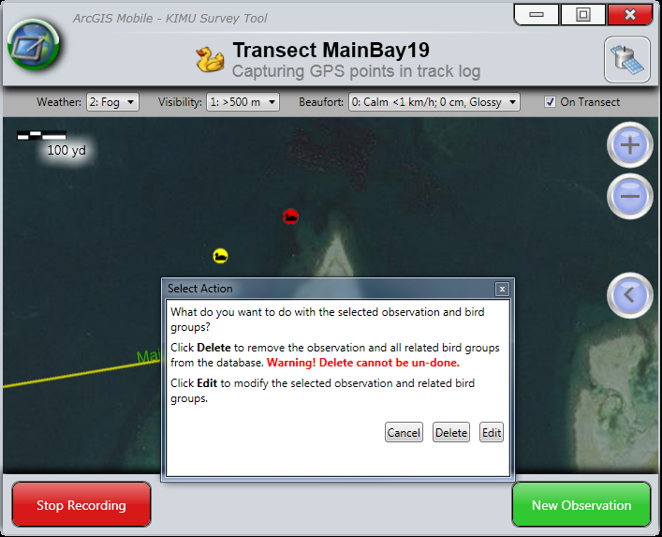

If you click Delete, the observation and all related bird groups will be removed from the screen and delete from the database without any further action. You cannot undo this action, and all record of where that observation occurred is lost. If you click edit, the Edit Observation Attrributes page will open, and you will be able to edit the observation as discussed in the previous section.

### Misc Notes

Closing the application at any time will save any open observations and track logs (an observation cannot be saved if it is not valid) before closing.

If the application loses connectivity with the GPS (for example, cable disconnects, batteries die, GPS is turned off, etc), then the application will save any open observations and track logs (an observation cannot be saved if it is not valid), and return to the starting page.

# Editing in ArcMap

It is possible to make minor corrections to the data in ArcMap at the end of the day. These changes should occur after running script C:\KIMU\Scripts\3)SyncUser.bat and before running script C:\KIMU\Scripts\4)ExportToCSV.bat. In general, this document assumes you know how to edit data in ArcMap, so this section only contains details on the highlights that are unique to the data in this application.

Use caution when editing project data in ArcMap. If the relationships are not properly maintained, then it may be that the save cannot be committed until the relationships are corrected, or it may be that the save will commit, but incorrect results will be reported in the CSV export.

1. Open C:\KIMU\Murrelets.mxd in ArcMap
2. Start editing.
3. Transects
   1. Should never be edited.
   2. In particular, never deleted or rename a transect, as they are referenced by name by track logs
4. Tracks
   1. Any of the non-spatial attributes can be edited, i.e. transect, weather, on/off transect, etc.
   2. Deleting a track is permissible, but not advised. It is better to mark a track as off transect. If you delete a track then all related GPS points, observation and bird groups also need to be deleted. ArcMap should do the cascading delete for you (my observation is that if you a save edits first the cascading delete is successful, however if there are unsaved edits, then the cascading delete does not happen correctly). If ArcMap does not delete related records, then you must do so manually.
   3. If you want to change attributes on only a portion of a track, you split the track into two tracks:
      1. Use the line split tool to split a track into two tracks. Turn on snapping, so that the split happens at a vertex (GPS point). Do not split the track at a vertex that has an observation.
      2. Select only the track that will get the new attribute, and change the attributes as needed.
      3. Adjust the start and end time of the two tracks, so that the appropriate value matches the time of the GPS point at the split point. Copy and paste the local time of the GPS point. Note that the start and end times of the tracks are based on the laptop clock not the GPS time, so they may not match the GPS points exactly. It is not critical the time on the tracks is exact, as it is only used for sorting the tracks.
      4. Give the modified segment a new ID.
         1. In the fields tab of the Tracks layer properties, make the Global ID and Track ID fields visible.
         2. Select the modified track
         3. Copy and paste the value of the Global ID to the Track ID
      5. Duplicate the GPS point at the intersection of the two tracks. This is the point where the split was made. The new GPS point will be related to the modified track, whereas the original GPS point will be related to the unmodified track. The easiest way to do this is with copy/paste. You may need to save edits after the paste in order for the results to correctly display.
      6. Change the GPS Point ID of the new GPS point using the same process used for the changing the track’s track ID
      7. Relate the GPS points to the correct track log.
         1. Select the modified track and all the GPS points touching the track, be sure to select one (but only one) at each end.
         2. In the attributes view, browse to the GPS Points under the selected track, right click and select **Add Selected** as shown here: 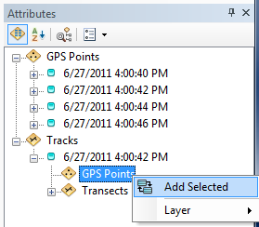
         3. You may need to save edits before the results will display correctly.
5. GPS Points
   1. GPS points should never be edited, except as required when splitting a track.
   2. Do not move GPS points, this will cause the spatial location and the attribute location (lat/long) to be out of sync, and incorrect values will be reported in the CSV file.
   3. Do not create new GPS points, except as required when splitting a track.
6. Observations
   1. If either of the non-spatial attributes, i.e. angle or distance, must be edited then the related bird groups must be moved. See the instructions for editing Bird Groups.
   2. You can delete an observation. ArcMap should (but does not always) delete the related bird groups. Before deleting an observation, identify the related bird groups, so that you can verify that they are also deleted. If ArcMap does not delete them for you, then delete the related bird groups manually.
   3. Adding a new observation
      1. An observation can only be created at an existing GPS point. To avoid possible confusion, it is best to not create observations at the intersection of two tracks.
      2. Turn on snapping so that the new observation is always added on top of an existing GPS point.
      3. Relate the observation to the GPS point using the method described for relating GPS points to a track.
      4. Edit the Angle and Distance attributes.
      5. Create 1 or more new bird groups at the correct angle and distance. See the following section for details.
7. Bird Groups
   1. Any of the non-spatial attributes, i.e. group size, species, behavior or comments can be easily edited.
   2. Deleting a bird group is permitted, however if you delete the last bird group related to an observation, then you must also delete the observation point.
   3. Moving a Bird Group
      1. If you move a bird group, you must move all the bird groups related to an observation, and you must adjust the angle and/or distance attributes of the related observation
      2. Move the bird group to the related observation. Hint use snapping.
      3. Get the value of bearing field for the GPS point related to the observation, and the angle of the observation, hint select the bird group and use the attributes view to browse to the related data.
      4. Add the angle to the bearing and then subtract 180 (an angle of 180 is dead ahead, i.e. the boat bearing), and write this number down on a scratch pad along with the distance in the observation
      5. Select **Options…** in the Editor menu (on the Editor toolbar), and on the **Units** tab, ensure that the **Direction Type** is set to **North Azimuth**.
      6. Create a new (temporary) track by snapping the first point to the related observation, and create the second point at the appropriate angle/distance (use ctrl-G or right click for the context menu).
      7. Move the bird group(s) to the end of the new temporary track
      8. Delete the temporary track.
   4. Creating a new bird group
      1. All bird groups must be related to an existing observation. Create an observation first if necessary.
      2. All bird groups must be located at the angle and distance specified in the related observation
      3. If this is a new bird group for an existing observation, then create the new bird group on top (use snapping) of the existing bird group(s) for that observation, if not then create the new bird group in the vicinity of the related observation.
      4. Edit the attributes (group size, species, behavior, comments) as appropriate
      5. Related the bird group to the related observation using the method described for relating GPS points to a track.
      6. Move the bird group to the correct position if necessary.
8. Stop editing, save edits if prompted.
9. Close ArcMap without saving changes to the document.

# Database Schema

The project data is stored in an ESRI file geodatabase (C:\KIMU\Murrelets.gdb). There are five feature classes that store all the project data. These feature classes are in a Feature Class Dataset called UTM8 that enforces a projection of UTM 8N (NAD83 Datum) on all the feature classes. The feature classes are related to each other as follows:

1. Each **bird group** has exactly one related observation; multiple bird groups may be related to the same observation.
2. Each **observation** has exactly one related GPS point. There should never be more than one observation related to a given GPS point. Each observation should have at least one bird group related to it.
3. Each **GPS point** has exactly one related Track. There should be exactly one related GPS point at each vertex of each track. (There will be two GPS points where the ends of two adjacent tracks meet, one related to each of the tracks.)
4. Each **track** has exactly one related transect. Multiple tracks may be related to the same transect.
5. A **transect** may have zero or more tracks related to it.

The requirements identified by the word should with an underline are enforced by the application not the file geodatabase. These relationships can become corrupted with improper editing in ArcMap.

## Transects Feature Class

|  |  |  |
| --- | --- | --- |
| Column | Data Type | Notes |
| ObjectID | Integer(32bit) | Managed by GIS; see note below |
| GlobalID | Guid | Managed by GIS; see note below |
| Shape | Blob | Managed by GIS; only editable with spatial tools |
| Shape_Length | Double | Managed by GIS; not editable; length of the transect |
| TransectID | Text(20) | Name of the transect |
| Sample | Integer(16bit) | Sampling interval  1=permanent panel, sampled annually,  2 through 4=panels sampled on a 3-year rotation, 2=2010, 2013, …, 3=2011, 2014,…  5=alternate transects to be used if primary transects can't be sampled |
| XOffset | Integer(16bit) | Provided by Steve Hoekman (used by him for labeling) |
| YOffset | Integer(16bit) | Provided by Steve Hoekman (used by him for labeling) |
| Angle | Integer(16bit) | Provided by Steve Hoekman (used by him for labeling) |

## Tracks Feature Class

|  |  |  |  |  |
| --- | --- | --- | --- | --- |
| Column | | Data Type | | Notes |
| ObjectID | Integer(32bit) | | Managed by GIS; see note below | |
| GlobalID | Guid | | Managed by GIS; see note below | |
| Shape | Blob | | Managed by GIS; only editable with spatial tools | |
| Shape_Length | Double | | Managed by GIS; not editable; length of the track | |
| TrackID | Guid | | Primary key, assigned by application, or when editing in ArcMap | |
| TransectID | Text(20) | | Foreign key to TransectID column in Transect Feature Class | |
| Vessel | Text(12) | | Name of the vessel | |
| Recorder | Text(12) | | Name of the data recorder | |
| Observer1 | Text(12) | | Name of the first observer | |
| Observer2 | Text(12) | | Name of the second (optional) observer | |
| Start | Datetime | | Time on laptop clock when track recording started | |
| End | Datetime | | Time on laptop clock when track recording ended | |
| Visibility | Integer(32bit) | | Code for seeing distance in meters  1: >500 m  2: 250-500 m  3: <250 m | |
| Weather | Integer(32bit) | | Weather conditions  0: <50% Cloud cover  1: >50% Cloud cover  2: Fog  3: Mist – Light rain  4: Moderate – Heavy rain | |
| Beaufort | Integer(32bit) | | Beaufort Scale for Sea State  0: Calm <1 km/h; 0 cm, Glossy  1: Light air 1-3 km/h; 0-20 cm, Ripples  2: Light breeze 3-7 km/h; 20-50 cm, Few whitecaps  3: Gentle breeze 8-12 km/h; 50-100 cm, Scattered whitecaps  4: Moderate breeze 13-17 km/h; 1-2 m, Frequent whitecaps, spray | |
| Protocol_ID | Text(50) | | Name of the data collection protocol being observed | |
| OnTransect | Text(5) | | “True”: location is being recorded and observations can be made  “False”: location is being recorded but observations are not being made. | |

## GpsPoints Feature Class

|  |  |  |  |  |
| --- | --- | --- | --- | --- |
| Column | | Data Type | | Notes |
| ObjectID | Integer(32bit) | | Managed by GIS; see note below | |
| GlobalID | Guid | | Managed by GIS; see note below | |
| Shape | Blob | | Managed by GIS; only editable with spatial tools | |
| GpsPointID | Guid | | Primary key, assigned by application, or when editing in ArcMap | |
| TrackID | Guid | | Foreign key to TrackID column in Tracks Feature Class | |
| Lat_dd | Double | | Latitude as reported in the NMEA sentence by the GPS device converted to decimal degrees if necessary | |
| Long_dd | Double | | Longitude as reported in the NMEA sentence by the GPS device converted to decimal degrees if necessary | |
| Time_utc | Datetime | | Universal date/time as reported in the NMEA sentence by the GPS device | |
| Time_local | Datetime | | Time_utc converted to local time using the Timezone information in the laptop | |
| HDOP | Double | | Horizontal degree of precision. A measure of the accuracy of the GPS coordinates as reported in the NMEA sentence by the GPS device | |
| Satellite_Count | Integer(32bit) | | Number of satellites used to fix the location (less than or equal to the number of visible satellites) as reported in the NMEA sentence by the GPS device | |
| Speed | Double | | Speed of the vessel in kilometers per hour as reported in the NMEA sentence by the GPS device | |
| Bearing | Double | | Bearing of the GPS in degrees azimuth north as reported in the NMEA sentence by the GPS device. | |
| GPS_Fix_Status | Integer(32bit) | | GPS Status as reported in the NMEA sentence by the GPS device  0: No fix on the location  1: Standard GPS fix  2: Differential GPS fix  3-8: possible values that are not used. | |

## Observations Feature Class

|  |  |  |  |  |
| --- | --- | --- | --- | --- |
| Column | | Data Type | | Notes |
| ObjectID | Integer(32bit) | | Managed by GIS; see note below | |
| GlobalID | Guid | | Managed by GIS; see note below | |
| Shape | Blob | | Managed by GIS; only editable with spatial tools | |
| ObservationID | Guid | | Primary key, assigned by application, or when editing in ArcMap | |
| GpsPointID | Guid | | Foreign key to GpsPointID column in GpsPoints Feature Class | |
| Angle | Integer(32bit) | | 0 to 360  Angle in degrees from the observer to the bird. 0 and 360 are dead astern, 90 is port, 180 is dead ahead, 270 is starboard | |
| Distance | Integer(32bit) | | 1 to 500  Distance in meters from the observer to the bird group. | |

## BirdGroups Feature Class

|  |  |  |  |  |
| --- | --- | --- | --- | --- |
| Column | | Data Type | | Notes |
| ObjectID | Integer(32bit) | | Managed by GIS; see note below | |
| GlobalID | Guid | | Managed by GIS; see note below | |
| Shape | Blob | | Managed by GIS; only editable with spatial tools | |
| ObservationID | Guid | | Foreign key to ObservationID column in Observations Feature Class | |
| GroupSize | Integer(32bit) | | Number of birds in this group 1 to 99 | |
| Behavior | Text(1) | | “W”: Water (floating of diving)  “F”: Flying | |
| Species | Text(1) | | “K”: Kitlitz’s murrelet  “M”: marbled murrelet  “U”: Unidentified, and that is final  “P”: Unidentified, but hoping for positive identification | |
| Comments | Text(255) | |  | |

Notes:

1. The ObjectID, and GlobalID fields are in all tables and are managed by GIS. They are not editable. They are volatile and therefore not suitable for use as a primary key. The ObjectID is used in map display, and the Global ID is used for syncing records between the file geodatabase and the mobile cache.
2. Double is a 64 bit real (floating point) value. The precision and scale are not documented, and it is assumed to be determined by the hardware.
3. Guid is a globally unique identifier
4. Datetime is an ESRI data type that stores the date and time in an undocumented format.

# Miscellaneous

## Contact Information

This application was developed by the Alaska Region GIS Team of the National Park Service.

Regan Sarwas

GIS Programmer

National Park Service, Alaska Region

240 West 5th Avenue

Anchorage, AK 99501

regan_sarwas@nps.gov

907-644-3548

This application was developed for the Southeast Alaska Inventory and Monitoring Network of the National Park Service.

Brendan Moynahan

SEAN I&M Coordinator

National Park Service, Glacier Bay National Park & Preserve

brendan_moynahan@nps.gov

907-364-2621

## Script Details

### C:\KIMU\Scripts\1)InstallOrUpdateMachine.bat

This script needs to be run at least once per machine after ArcGIS mobile is installed. It should be run again if ArcGIS Mobile or the Murrelet Survey Tool is upgraded.

### C:\KIMU\Scripts\2)InstallOrUpdateUser.bat

This script needs to be run at least once for each data recorder. It should be run again if

* Script 1 is run
* The background imagery is updated
* The database schema changes
* the layer properties in C:\KIMU\Murrelets (sync).mxd change

### C:\KIMU\Scripts\3)SyncUser.bat

This script can be run as often as desired, but should always be run before running script 4.

### C:\KIMU\Scripts\4)ExportToCSV.bat

This script can be run as often as desired, but daily is the minimum suggested. The results will only differ from the previous run if script 3 has been run first. Each run will overwrite the output from the previous run. Be sure that the csv file is not open in Excel when this script is run, or it will fail.

### C:\KIMU\Scripts\5)SnapshotToZip.bat

This script should run as often as desired. It is suggested that it be run each time script 4 is run. If the script is run more than once in a day, it will overwrite the previous output for that day. Please remember to close any ArcMap documents than may have the murrelet data open before running this script or it will generate errors because some files in the file geodatabase are locked by ArcMap.

## Field Checklist

* GPS output is set to NMEA
* GPS output is set to WGS84
* Laptop time zone and daylight savings time are correct

## Notes

* Record Track Log Page: After deleting an observation/birdgroup, it takes about 1 second for the map to redraw.
* Edit Observation Page: If any birdgroup is not valid when new observation is clicked, then any edits in that birdgroup will be lost.
* If you lose GPS connection (batteries run out, cable disconnect), then all data will be saved, and the application will return to the starting map page. You can then try an re-establish GPS connection and restart recording on the tracklog. The tracklog page will remember all previous settings.
* If the GPS loses signal, then the boat will not move, and will appear ghosted (mostly translucent). You can operate as normal, but the coordinates will be stale until the GPS gets a signal.

## Cautions

* Do not change the schema of the database or the layer properties in **Murrelet (sync).mxd** while data collecting (i.e. in between syncs between the database and the mobile device). Doing so will cause the sync to fail and the data in the mobile cache will be lost. You will need to update the schema in the mobile cache (script2) before you can sync.
* Do not change the schema of the database without coordinating with the programmer. Most schema changes will require changes to the application code.
* Do not change visibilities of fields in **Murrelet (sync).mxd**. This constitutes a change to the mobile schema, and may cause the application or syncing to fail.
* Do not use the identify tool in the mobile application to delete items (the mobile application does not honor relationships and it will create orphaned data)
* Enter key in all pages goes to the next page, not next field.
* The application will not load multiple transects with the same name.
* Treat transects as immutable (i.e. do not change them). In particular, do not delete, move or rename existing transects once a track log has been recorded against it.
* Be very careful editing project data in ArcMap, and be sure to follow the guidelines in Editing in ArcMap.

## Trouble Shooting

* If GPS location is outside the extents of the map (Glacier Bay) then the display will be blank, and it will not be possible to use the application.
* Be sure to check the definition queries in Murrelets (sync).mxd and ensure that the correct year and transect panels are being selected for import/export
* Do not use joins in Murrelets (sync).mxd. If there is a join on a layer, then that layer will not export to the mobile cache, even if the joined fields are only used for filtering the data and are not visible (not intended to be exported to the mobile cache).

1. Other configurations may work, but have not been tested.
2. There should only ever be one copy of C:\KIMU\Murrelet.gdb as the master database. If two copies are used concurrently, data will be fragmented and difficult to merge. It is the user’s responsibility to maintain control of the master copy of C:\KIMU\murrelet.gdb.